TITLE: - CONVENTION MEMORY

AIM: -
To write a program to find info of the Keyboard special keys state and display the Key state ( On/Off)
ALGORITHM: -
· Initialize data segment.
· Display the header message.
· Execute BIOS INT 16h (Function 02h) to read keyboard status flags.
· Save the keyboard flags returned in the AL register.
· Test bit 6 and display Caps Lock status (ON/OFF).
· Test bit 5 and display Num Lock status (ON/OFF).
· Test bit 4 and display Scroll Lock status (ON/OFF).
· Test bit 7 and display Insert Key status (ON/OFF).
· Test bits 0 and 1 and display Shift Key status (ON/OFF).
· Test bit 2 and display Ctrl Key status (ON/OFF).
· Test bit 3 and display Alt Key status (ON/OFF).
· Terminate program execution.
PROGRAM:-
TITLE KeySp.ASM -- Display Keyboard Special Key Status

;//***********************************************************************
;//* *
;//* Copyright (c) 1985-2025, American Megatrends International LLC. *
;//* *
;//* All rights reserved. Subject to AMI licensing agreement. *
;//* *
;//***********************************************************************

;<AMI_FHDR_START>
;
; Header:
; Author: Muthuganesh S
; Description:
; Program to read and display keyboard special key states
; like Caps Lock, Num Lock, Scroll Lock, Insert,
; Shift, Ctrl and Alt using BIOS keyboard status.
;
;<AMI_FHDR_END>

.model small
.386
.stack 100h

;----------------------------------------------------------------------------
; DATA SEGMENT
;----------------------------------------------------------------------------
data segment

msg1 db 13,10,"Keyboard Special Key Status",13,10,13,10,'$'

capsmsg db "Caps Lock : $"
nummsg db 13,10,"Num Lock : $"
scrollmsg db 13,10,"Scroll Lock : $"
insertmsg db 13,10,"Insert Key : $"
shiftmsg db 13,10,"Shift Key : $"
ctrlmsg db 13,10,"Ctrl Key : $"
altmsg db 13,10,"Alt Key : $"

onmsg db "ON$"
offmsg db "OFF$"

keystate db ?

data ends
;----------------------------------------------------------------------------

;----------------------------------------------------------------------------
; CODE SEGMENT
;----------------------------------------------------------------------------
code segment
assume cs:code, ds:data

start:

mov ax, data
mov ds, ax

;--------------------------------------------------
; Display Header
;--------------------------------------------------
mov dx, offset msg1
mov ah, 09h
int 21h

;--------------------------------------------------
; BIOS Keyboard Status
; INT 16h Function 02h
; Returns keyboard flags in AL
;--------------------------------------------------
mov ah, 02h
int 16h

mov keystate, al

;--------------------------------------------------
; Caps Lock Status (Bit 6)
;--------------------------------------------------
mov dx, offset capsmsg
mov ah, 09h
int 21h

test keystate, 01000000b
jz caps_off

caps_on:
mov dx, offset onmsg
jmp caps_print

caps_off:
mov dx, offset offmsg

caps_print:
mov ah, 09h
int 21h

;--------------------------------------------------
; Num Lock Status (Bit 5)
;--------------------------------------------------
mov dx, offset nummsg
mov ah, 09h
int 21h

test keystate, 00100000b
jz num_off

num_on:
mov dx, offset onmsg
jmp num_print

num_off:
mov dx, offset offmsg

num_print:
mov ah, 09h
int 21h

;--------------------------------------------------
; Scroll Lock Status (Bit 4)
;--------------------------------------------------
mov dx, offset scrollmsg
mov ah, 09h
int 21h

test keystate, 00010000b
jz scroll_off

scroll_on:
mov dx, offset onmsg
jmp scroll_print

scroll_off:
mov dx, offset offmsg

scroll_print:
mov ah, 09h
int 21h

;--------------------------------------------------
; Insert Key Status (Bit 7)
;--------------------------------------------------
mov dx, offset insertmsg
mov ah, 09h
int 21h

test keystate, 10000000b
jz insert_off

insert_on:
mov dx, offset onmsg
jmp insert_print

insert_off:
mov dx, offset offmsg

insert_print:
mov ah, 09h
int 21h

;--------------------------------------------------
; Shift Key Status (Bits 0 and 1)
;--------------------------------------------------
mov dx, offset shiftmsg
mov ah, 09h
int 21h

test keystate, 00000011b
jz shift_off

shift_on:
mov dx, offset onmsg
jmp shift_print

shift_off:
mov dx, offset offmsg

shift_print:
mov ah, 09h
int 21h
;--------------------------------------------------
; Ctrl Key Status (Bit 2)
;--------------------------------------------------
mov dx, offset ctrlmsg
mov ah, 09h
int 21h
test keystate, 00000100b
jz ctrl_off

ctrl_on:
mov dx, offset onmsg
jmp ctrl_print
ctrl_off:
mov dx, offset offmsg
ctrl_print:
mov ah, 09h
int 21h
;--------------------------------------------------
; Alt Key Status (Bit 3)
;--------------------------------------------------
mov dx, offset altmsg
mov ah, 09h
int 21h

test keystate, 00001000b
jz alt_off

alt_on:
mov dx, offset onmsg
jmp alt_print

alt_off:
mov dx, offset offmsg

alt_print:
mov ah, 09h
int 21h

;--------------------------------------------------
; Exit Program
;--------------------------------------------------
mov ah, 4Ch
int 21h

code ends
end start
OUTPUT: -
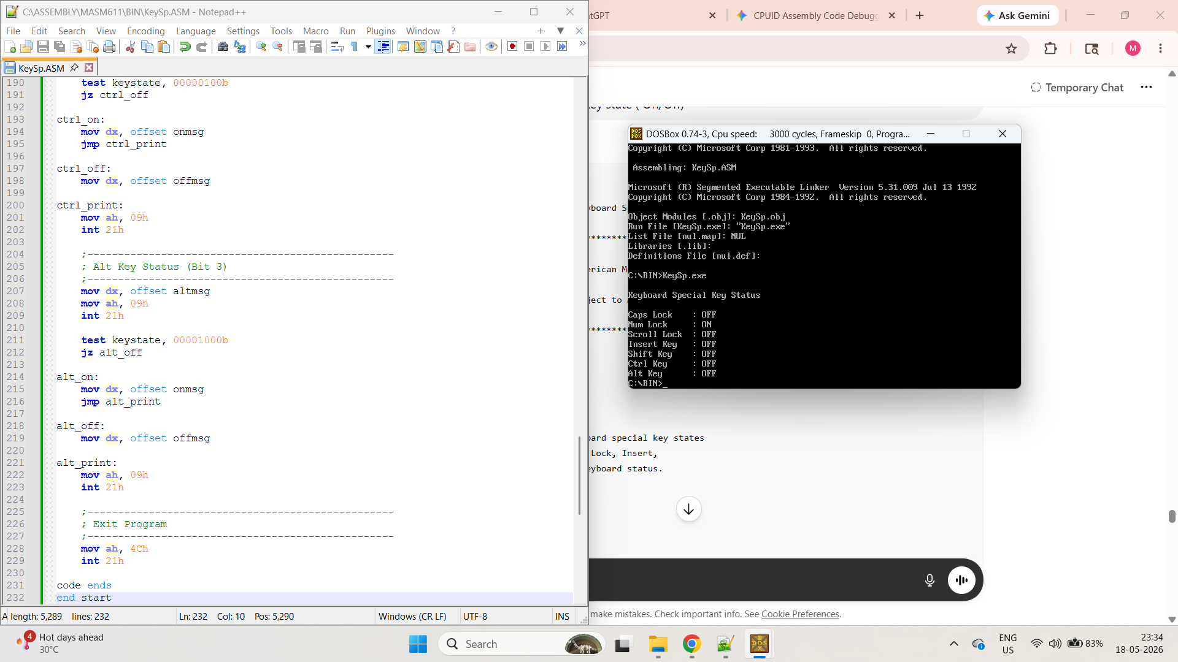

AIM: -
To display the starting address of EBDA and Size of the EBDA

ALGORITHM: -
· Initialize the data segment.
· Display the header message.
· Read the EBDA segment address from the BIOS Data Area at memory location 0040:000E.
· Call the subroutine to convert and display the segment address in hexadecimal.
· Calculate the 32-bit physical address by shifting the segment address left by 4 bits (multiplying by 16).
· Call the subroutine to convert and display the physical address in hexadecimal.
· Read the first byte of the EBDA segment to retrieve its size in Kilobytes.
· Display the EBDA size in both hexadecimal and formatted string outputs.
· Terminate program execution.
PROGRAM:-
TITLE EBDA.ASM -- Display EBDA Start Address and Size

;//***********************************************************************
;//* *
;//* Copyright (c) 1985-2025, American Megatrends International LLC. *
;//* *
;//* All rights reserved. Subject to AMI licensing agreement. *
;//* *
;//***********************************************************************

;<AMI_FHDR_START>
;
; Header:
; Author: Muthuganesh S
; Description:
; Program to display the starting address and size
; of Extended BIOS Data Area (EBDA).
;
;<AMI_FHDR_END>

.model small
.386
.stack 100h

;----------------------------------------------------------------------------
; DATA SEGMENT
;----------------------------------------------------------------------------
data segment

msg1 db 13,10,"EBDA Information",13,10,13,10,'$'

msg2 db "EBDA Segment Address : 0x$"
msg3 db 13,10,"EBDA Physical Address: 0x$"
msg4 db 13,10,"EBDA Size : 0x$"

hexbuf db '0000$'
hexbuf32 db '00000000$'

ebda_seg dw ?
ebda_size db ?

data ends
;----------------------------------------------------------------------------

;----------------------------------------------------------------------------
; CODE SEGMENT
;----------------------------------------------------------------------------
code segment
assume cs:code, ds:data

start:

mov ax, data
mov ds, ax

;--------------------------------------------------
; Print Header
;--------------------------------------------------
mov dx, offset msg1
mov ah, 09h
int 21h

;--------------------------------------------------
; EBDA Segment Pointer
; BIOS Data Area
; 0040:000E
;--------------------------------------------------
mov ax, 0040h
mov es, ax

mov ax, es:[000Eh]
mov ebda_seg, ax

;--------------------------------------------------
; Print EBDA Segment Address
;--------------------------------------------------
mov dx, offset msg2
mov ah, 09h
int 21h

mov ax, ebda_seg
call PrintHexWord

;--------------------------------------------------
; Calculate Physical Address
; Physical = Segment * 16
;--------------------------------------------------
movzx eax, ebda_seg
shl eax, 4

;--------------------------------------------------
; Print Physical Address
;--------------------------------------------------
mov dx, offset msg3
mov ah, 09h
int 21h

call PrintHexDword

;--------------------------------------------------
; Read EBDA Size
; First byte of EBDA contains size in KB
;--------------------------------------------------
mov ax, ebda_seg
mov es, ax

mov al, es:[0000h]
mov ebda_size, al

;--------------------------------------------------
; Print EBDA Size
;--------------------------------------------------
mov dx, offset msg4
mov ah, 09h
int 21h

xor ah, ah
mov al, ebda_size

call PrintHexWord

mov dl, 'h'
mov ah, 02h
int 21h

mov dl, ' '
int 21h

mov dl, '('
int 21h

mov al, ebda_size
add al, '0'

mov dl, al
int 21h

mov dl, 'K'
int 21h

mov dl, 'B'
int 21h

mov dl, ')'
int 21h

;--------------------------------------------------
; Exit Program
;--------------------------------------------------
mov ah, 4Ch
int 21h

;----------------------------------------------------------------------------
; PrintHexWord Procedure
;----------------------------------------------------------------------------
PrintHexWord proc

push ax
push bx
push cx
push dx
push si

mov si, offset hexbuf
mov cx, 4

hex_loop1:

rol ax, 4

mov bl, al
and bl, 0Fh

cmp bl, 9
jbe digit1

add bl, 7

digit1:
add bl, '0'

mov [si], bl
inc si

loop hex_loop1

mov dx, offset hexbuf
mov ah, 09h
int 21h

pop si
pop dx
pop cx
pop bx
pop ax

ret

PrintHexWord endp

;----------------------------------------------------------------------------
; PrintHexDword Procedure
;----------------------------------------------------------------------------
PrintHexDword proc

push eax
push ebx
push ecx
push edx
push si

mov si, offset hexbuf32
mov cx, 8

hex_loop2:

rol eax, 4

mov bl, al
and bl, 0Fh

cmp bl, 9
jbe digit2

add bl, 7

digit2:
add bl, '0'

mov [si], bl
inc si

loop hex_loop2

mov dx, offset hexbuf32
mov ah, 09h
int 21h

pop si
pop edx
pop ecx
pop ebx
pop eax

ret

PrintHexDword endp

code ends
end start
OUTPUT: -
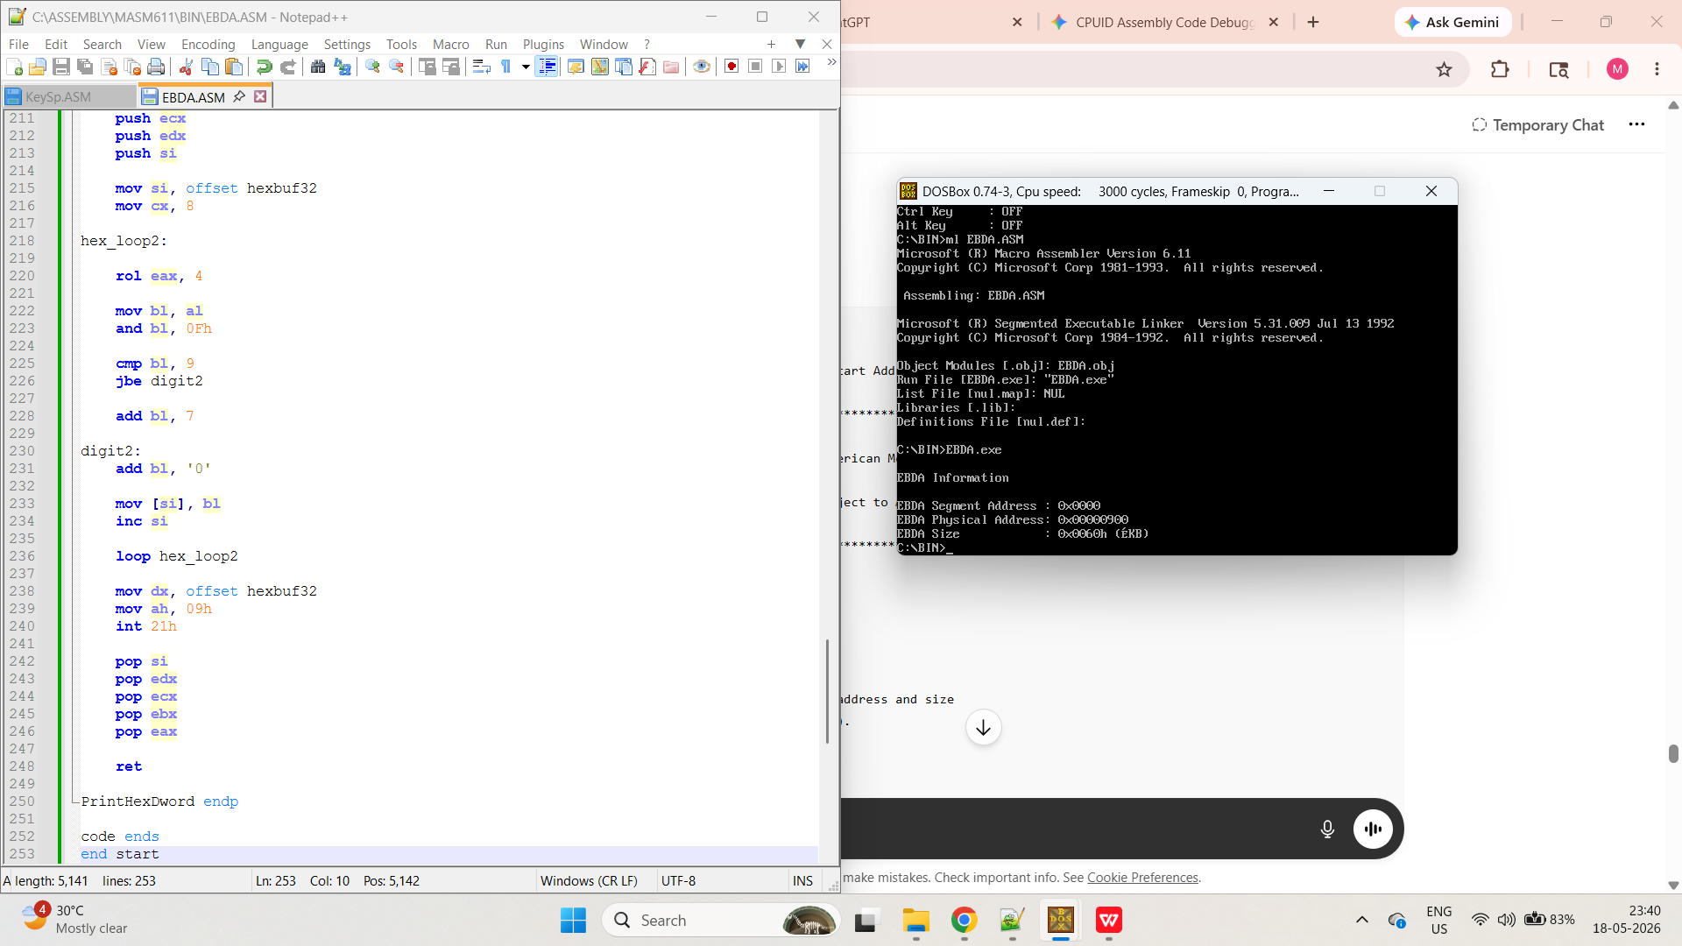

AIM: -
To write a program to verify the presence and no. of Option ROM’s available in the system and transfer the program control to VGA OpROM and regain the control back in the program.
ALGORITHM: -
· Initialize the data segment.
· Display the scanning start message.
· Set the initial memory segment pointer to C000h.
· Check the first two bytes of the current segment for the valid Option ROM signature (55h and AAh).
· If a valid signature is found, increment the ROM counter and display the detected segment address.
· If the detected ROM is at segment C000h (VGA ROM), execute a far call to C000:0003 and regain control afterward.
· Read the ROM size byte at offset 2 and convert it into a segment increment value.
· Add the increment value to the current segment pointer to jump to the next potential ROM boundary.
· Repeat the scanning loop until the segment pointer reaches F000h.
· Display the total count of discovered Option ROMs.
· Terminate program execution.
PROGRAM:-
TITLE OPROM.ASM -- Detect Option ROM and Transfer Control to VGA ROM

;//***********************************************************************
;//* *
;//* Copyright (c) 1985-2025, American Megatrends International LLC. *
;//* *
;//* All rights reserved. Subject to AMI licensing agreement. *
;//* *
;//***********************************************************************

;<AMI_FHDR_START>
;
; Header:
; Author: Muthuganesh S
; Description:
; Program to scan Option ROM area, detect available
; Option ROMs, count them and transfer control to
; VGA Option ROM and regain control back.
;
;<AMI_FHDR_END>

.model small
.386
.stack 100h

;----------------------------------------------------------------------------
; DATA SEGMENT
;----------------------------------------------------------------------------
data segment

msg1 db 13,10,"Scanning Option ROM Area...",13,10,'$'
msg2 db 13,10,"Option ROM Found at Segment : $"
msg3 db 13,10,"Total Option ROM Count : $"
msg4 db 13,10,"Calling VGA Option ROM...",13,10,'$'
msg5 db 13,10,"Returned From VGA Option ROM",13,10,'$'

hexbuf db '0000$'
countbuf db '00$'

romcount db 0

data ends
;----------------------------------------------------------------------------

;----------------------------------------------------------------------------
; CODE SEGMENT
;----------------------------------------------------------------------------
code segment
assume cs:code, ds:data

start:

mov ax,data
mov ds,ax

;--------------------------------------------------
; Print Start Message
;--------------------------------------------------
mov dx, offset msg1
mov ah,09h
int 21h

;--------------------------------------------------
; Start Scan from C000h
;--------------------------------------------------
mov ax,0C000h
mov es,ax

scan_loop:

;--------------------------------------------------
; Check ROM Signature 55AAh
;--------------------------------------------------
mov bx,0

mov al, es:[bx]
cmp al,55h
jne next_segment

mov al, es:[bx+1]
cmp al,0AAh
jne next_segment

;--------------------------------------------------
; Valid ROM Found
;--------------------------------------------------
inc romcount

mov dx, offset msg2
mov ah,09h
int 21h

mov ax, es
call PrintHexWord

;--------------------------------------------------
; VGA ROM Usually at C000h
;--------------------------------------------------
mov ax, es
cmp ax,0C000h
jne skip_vga

mov dx, offset msg4
mov ah,09h
int 21h

;--------------------------------------------------
; Transfer Control to VGA ROM
; Entry Point = C000:0003
;--------------------------------------------------
pushf

db 09Ah
dw 0003h
dw 0C000h

mov dx, offset msg5
mov ah,09h
int 21h

skip_vga:

next_segment:

;--------------------------------------------------
; Get ROM Size
; Offset 2 = Size in 512-byte blocks
;--------------------------------------------------
mov al, es:[0002h]

cmp al,0
jne valid_size

mov al,1

valid_size:

xor ah,ah

;--------------------------------------------------
; Convert to Segment Increment
; 512 bytes = 20h paragraphs
;--------------------------------------------------
mov bx,20h
mul bx

;--------------------------------------------------
; ES = ES + Size
;--------------------------------------------------
mov bx,es
add bx,ax
mov es,bx

;--------------------------------------------------
; Continue Until F000h
;--------------------------------------------------
mov bx,es
cmp bx,0F000h
jb scan_loop

;--------------------------------------------------
; Print Total ROM Count
;--------------------------------------------------
mov dx, offset msg3
mov ah,09h
int 21h

mov al, romcount
call PrintHexByte

;--------------------------------------------------
; Exit Program
;--------------------------------------------------
mov ah,4Ch
int 21h

;----------------------------------------------------------------------------
; PrintHexWord Procedure
;----------------------------------------------------------------------------
PrintHexWord proc

push ax
push bx
push cx
push dx
push si

mov si, offset hexbuf
mov cx,4

hex_loop1:

rol ax,4

mov bl,al
and bl,0Fh

cmp bl,9
jbe digit1

add bl,7

digit1:

add bl,'0'

mov [si],bl
inc si

loop hex_loop1

mov dx, offset hexbuf
mov ah,09h
int 21h

pop si
pop dx
pop cx
pop bx
pop ax

ret

PrintHexWord endp

;----------------------------------------------------------------------------
; PrintHexByte Procedure
;----------------------------------------------------------------------------
PrintHexByte proc

push ax
push bx
push dx

mov bl,al

shr al,4
call HexAscii
mov countbuf[0],al

mov al,bl
and al,0Fh
call HexAscii
mov countbuf[1],al

mov dx, offset countbuf
mov ah,09h
int 21h

pop dx
pop bx
pop ax

ret

PrintHexByte endp

;----------------------------------------------------------------------------
; HexAscii Procedure
;----------------------------------------------------------------------------
HexAscii proc

cmp al,9
jbe digit2

add al,7

digit2:

add al,'0'

ret

HexAscii endp

code ends
end start
OUTPUT: -
